**Goal**: have a finished product that we can push to the app store

Task Listing:

**✅**User Story 1 (3) - “as a user I want to be able to see my posted listings on my profile page, so that I know what people are seeing who look me up”

* Task 1 (1 hour) integrate the post scroll view into the profile page
* Task 2 (2 hours) implement a filter on the posts so that only the posts of the person whose profile you are looking at show up

**✅**User Story 2 (2) - “As a user I do not want to see old profile information after I have just updated”

* Task 1 (2 hour) debug how to change images possibly with a loading animation or some other method

**✅**User Story 3 (12) - “As a user I want to be able to message other users in the app so that communication is easy and efficient”

* Task 1 (3 hours) - set up messaging database structure
* Task 2 (5 hours) - create ui
* Task 3 (3 hour) - effectively pull information from the back to use interface

❌User Story 4 - (5) “As a user I want to be able to see when a service provider is available so that I can make sure he can accept my job before I even talk to him”

…

❌User Story 5 - “As a user I want to be able to do something with locations ”

…

❌[Spike] User Story 5 (2 hours)- “implement some unit testing for some things to demonstrate ability for class ”

**✅**[Spike] Definition of done (1 hour) - “complete the definition of done documentation”

**✅**[Spike] Design Style Doc (1 hour) - “review notes and look fill out each category for this document”

**Added User Stories:**

(These tasks are related to the user stories from above, these tasks were not made when we first made our plan)

User Story 4:

**✅**Task 1 (5 hours) Create an availability tab view for the profile

User Story 5:

**✅**Task 1 (3 hours) create and store locations of users

BurnUp Chart: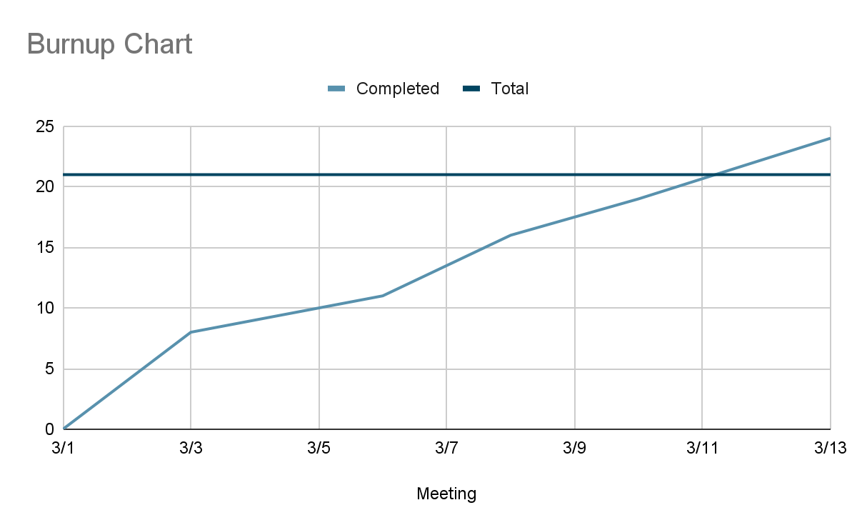

**Start:**

* Documentation work
* Preparing for presentation
* Sharing the app with others

**Stop:**

* Worrying about bugs
* Stop coding

**Continue:**

* Using the app
* Doing documentation and slideshow